Name_______________ Mr. Romero
Period______________ Current Issues

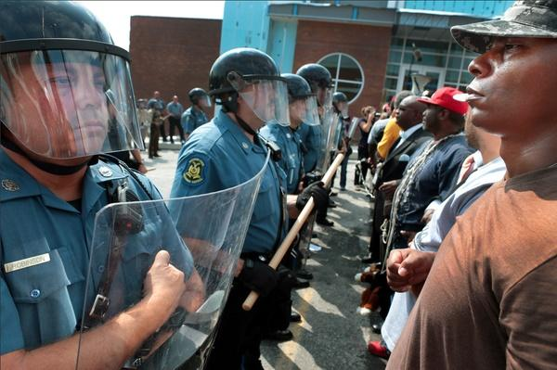

Current Issues

Course Outline and Expectations

Welcome, and bienvenidos to Mr. Romero’s Current Issues class. Please read this carefully as this course outline will provide you with the guidelines and foundation to be successful in Current Issues. This is a very fun and exciting course that deals with many current, trending issues; everything from foreign politics (the invasion of Ukraine by Russia) to new technology (the new Iphone, for example) and music. It is a great privilege and honor to be able to work with you this year, so work hard, have fun and enjoy the course!
Textbook
- There is no assigned textbook for this class; however, readings, articles, newspapers, magazines, and the internet will be used to aid in researching and studying trending topics.

Materials
- To be brought to class every day, unless instructed otherwise.
- Pens (black or blue only + one red pen for class grading) and paper.
- 3 ring binder about 2” thick and a folder to store articles.
- Contents in the notebook must be stored for 2 quarters (one semester)

Homework
It is expected that students will take pride in their work and that any work submitted will reveal a high level of preparation, thought and care. If it has your name on it, it is a reflection of you!
- May be written or typed, and must be submitted on time.
- YOU ARE RESPONSIBLE FOR SUBMITTING YOUR WORK ON TIME AND IN AN ACCEPTABLE MANNER.
- You may hand in your homework late without penalty only if you are absent or have a note from your parent.

Attendance
ALL students are expected to make a positive contribution to the class. You are expected to be on time and attend all classes. Students are expected to bring all necessary equipment and materials to class. You are expected to come to class ready to learn and contribute to the learning of others. Students are encouraged to actively participate (question, think critically, offer opinions, etc.) in all aspects of this class (discussions, group work, homework, assignments, presentations, etc.).
- Be on time and seated before the bell rings.
- For extended absences, contact a classmate or the school to keep as current with your work as possible.
- IT IS YOUR RESPONSIBILITY TO MAKE UP A QUIZ OR TEST IF YOU ARE ABSENT ON A DAY THAT IT IS GIVEN.

Marking System
- Student grades can be accessed at the school’s parent portal on eschooldata.com located on the school website.
- All work will be returned to you as soon as possible
- You are responsible for recording and retaining all your work for each quarter
- The marking system is as follows:
- Tests – 35 percent
- Presentations – 25 percent
- Homework and classwork – 15 percent
- Notebook check – 5 percent
- Projects – 10 percent
- Class participation 10 percent.
- THESE RATIOS ARE NOT SET IN STONE AND CAN CHANGE AT ANY TIME

Parental Contact
- I will call home if a problem arises in the classroom, either behavioral or academic.
- Check your child’s homework and returned work.
- Contact me at school, if, at any time, you have a concern or a question
- My email address is cromero@hbschools.us, and I check my email regularly.

Website
- I will be posting class information and homework assignments on my website: http://www.mrromeroonline.weebly.com/

Student Signature_______________ Parent Signature________________

